LINUX LAB 3
‎
‎Directory, File Management and I/O Redirection
‎ Name: Bazla Awan
‎Roll Number: F24-1187
‎Department: IT
‎Course Name: OPERATING SYSTEM
‎Semester / Section: 5th C
‎Submitted To: Sir Ihtisham
1. ‎Statement of Purpose
‎This lab introduces directory and file-related commands in Linux. It covers navigation through the Linux file system, working with directories, handling files, and using input/output (I/O) redirection.

‎Task 1: Display the current directory.
Task 2:Change to the /etc directory.
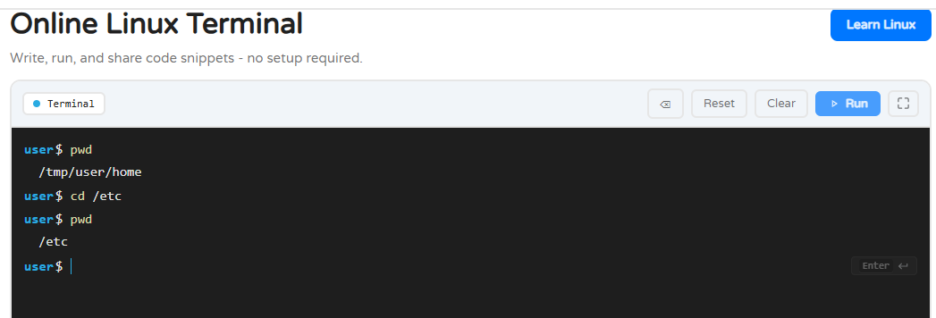
‎
‎Result: The "pwd" command displays the path of the current working directory.
‎cd /etc
‎Output:
‎No output displayed.
‎Verification command:
‎pwd
‎Expected output:
‎/etc
‎Result: The "cd" command changes the current working directory to "/etc".
‎
‎Task 3: Go to the parent directory of the current directory.
Task 4: Go to the root directory.

‎Command 3:
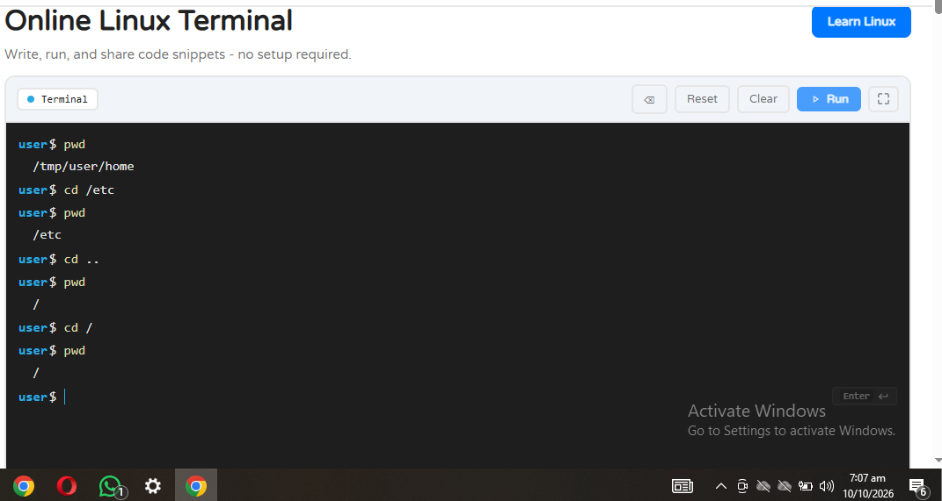
‎cd ..
‎Output:
‎No output displayed.
‎Verification command:
‎pwd
‎Expected output:
‎/
‎Result: The "cd .." command moves to the parent directory. When the current directory is "/etc", its parent is "/".
‎Command 4:
‎cd /
‎Output:
‎No output displayed.
‎Verification command:
‎pwd
‎Expected output:
‎/
‎Result: The command changes the current working directory to the root directory.

Task 5: List the contents of root directory.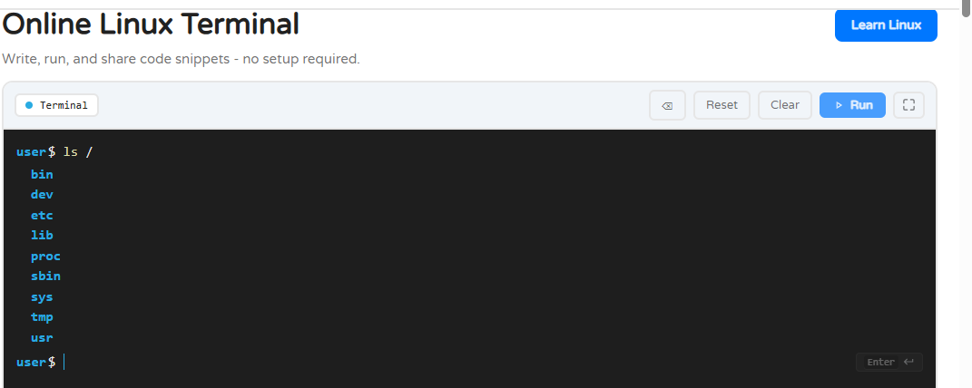

‎Command:
‎ls /
‎Sample output:
‎bin boot dev etc home lib media mnt opt proc root run sbin tmp usr var
‎Result: The "ls" command lists the files and directories present in the root directory.
‎Task 6: List a long listing of the root directory.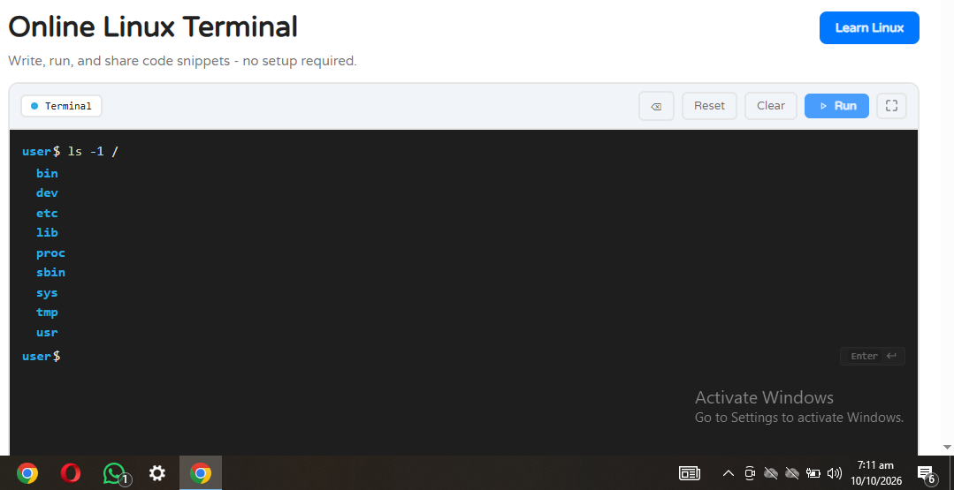
‎Command:
‎ls -l /
‎Sample output:
‎drwxr-xr-x 2 root root 4096 bin
‎drwxr-xr-x 2 root root 4096 boot
‎drwxr-xr-x 5 root root 360 dev
‎drwxr-xr-x 80 root root 4096 etc
‎
‎Result: The "-l" option displays detailed information about files and directories, including permissions, ownership, size, and modification time. The output varies between systems.
But my output was this as shown is picture.
‎
‎Task 7: Stay where you are and list the contents of /etc.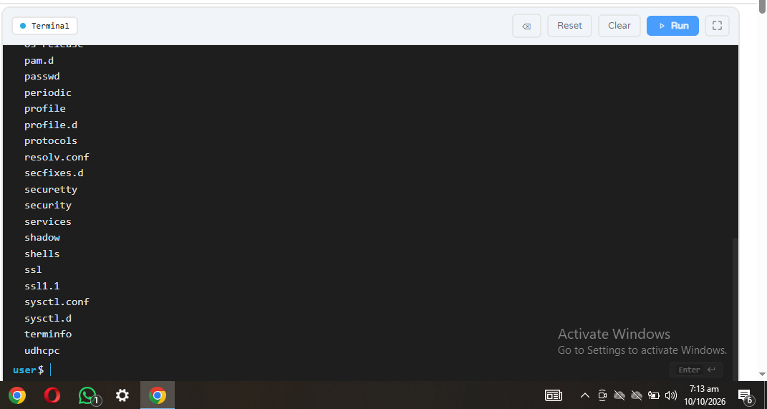
‎Command:
‎ls /etc
‎Sample output:
‎hostname hosts passwd profile resolv.conf services
‎Result: The command lists the contents of "/etc" without changing the current working directory.
These commands were large enough to be visible on the screen.
‎
‎Task 8: Stay where you are and list the contents of /bin and /sbin.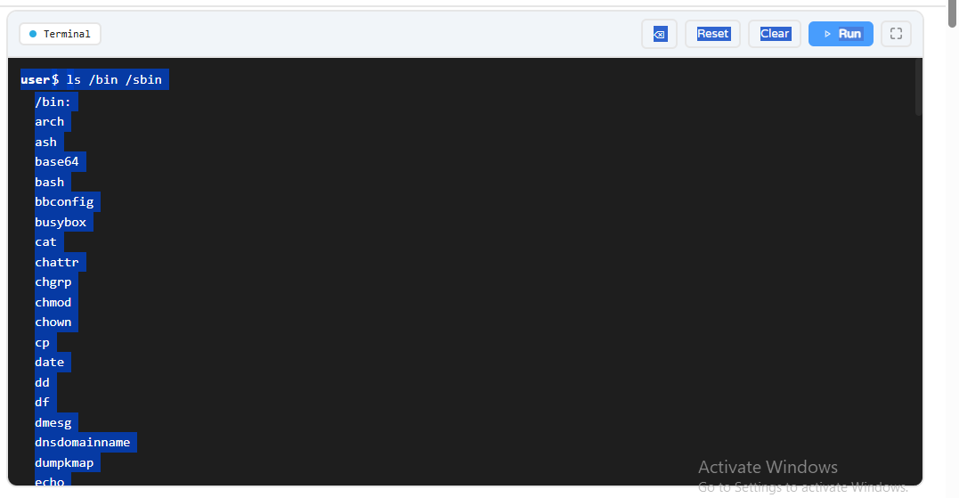
‎Command:
‎ls /bin /sbin
‎Sample output:
‎/bin:
‎bash cat cp ls mkdir mv rm
‎/sbin:
‎fsck reboot shutdown
‎Result: The command lists the contents of both "/bin" and "/sbin". The exact entries depend on the Linux system.
‎
‎Task 9: Stay where you are and list the contents of the home directory.
‎Task 10: List all files, including hidden files, in the home directory.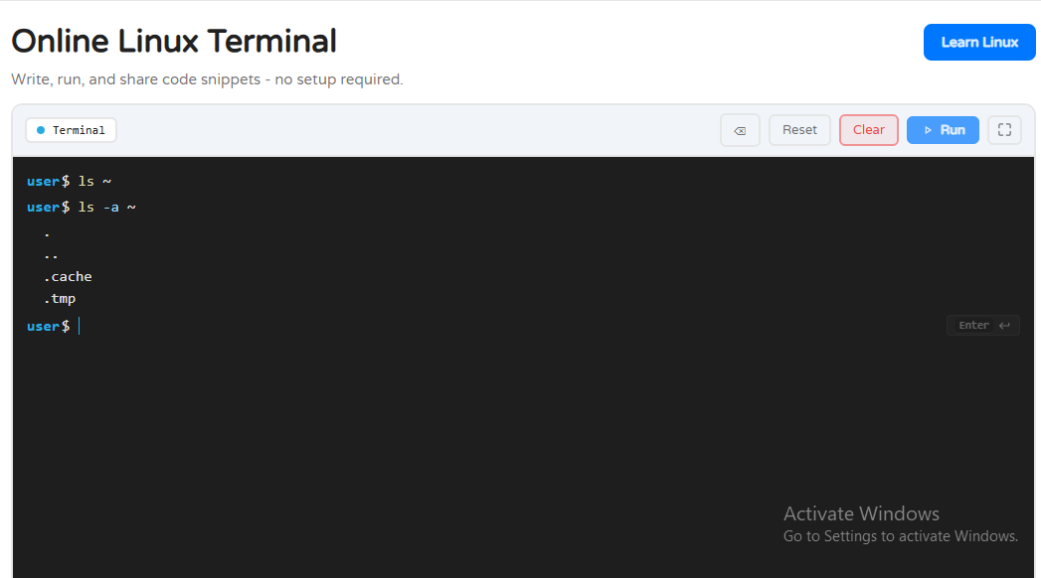
‎Command:
‎ls -a ~
‎Sample output:
‎. .. .cazhe .temp
‎Result: The "-a" option displays all entries, including hidden files whose names begin with a dot (".").
‎Command:
‎ls ~
‎Sample output:
‎Desktop Documents Downloads Pictures
‎Result: The tilde symbol ("~") represents the current user's home directory.
But on my terminal it was not showing results.
‎
‎Task 11: List the files in /boot in a human-readable format.
‎Command:
‎ls -lh /boot
‎Sample output:
‎total 12K
‎-rw-r--r-- 1 root root 2.1K example-file
‎Result: The "-l" option displays a detailed listing, while "-h" displays file sizes in human-readable units, such as KB, MB, or GB. The files shown depend on the system.
END OF LAB REPORT

‎
‎

